**WEEK 4**

**OS LAB**

Y. Shamil Ahamed

1BM21CS248.

Q1) Multi-Level Queue Scheduling Algorithm:

INPUT:

#include <stdio.h>

#define MAX_QUEUE_SIZE 100

// Structure to represent a process

typedef struct {

    int processID;

    int arrivalTime;

    int burstTime;

    int priority; // 0 for system process, 1 for user process

} Process;

// Function to execute a process

void executeProcess(Process process) {

    printf("Executing Process %d\n", process.processID);

    // Simulating the execution time of the process

    for (int i = 1; i <= process.burstTime; i++) {

        printf("Process %d: %d/%d\n", process.processID, i, process.burstTime);

    }

    printf("Process %d executed\n", process.processID);

}

// Function to perform FCFS scheduling for a queue of processes

void scheduleFCFS(Process queue[], int size) {

    for (int i = 0; i < size; i++) {

        executeProcess(queue[i]);

    }

}

int main() {

    int numProcesses;

    Process processes[MAX_QUEUE_SIZE];

    // Reading the number of processes

    printf("Enter the number of processes: ");

    scanf("%d", &numProcesses);

    // Reading process details

    for (int i = 0; i < numProcesses; i++) {

        printf("Process %d:\n", i + 1);

        printf("Arrival Time: ");

        scanf("%d", &processes[i].arrivalTime);

        printf("Burst Time: ");

        scanf("%d", &processes[i].burstTime);

        printf("System(0)/User(1): ");

        scanf("%d", &processes[i].priority);

        processes[i].processID = i + 1;

    }

    // Separate system and user processes into different queues

    Process systemQueue[MAX_QUEUE_SIZE];

    int systemQueueSize = 0;

    Process userQueue[MAX_QUEUE_SIZE];

    int userQueueSize = 0;

    for (int i = 0; i < numProcesses; i++) {

        if (processes[i].priority == 0) {

            systemQueue[systemQueueSize++] = processes[i];

        } else {

            userQueue[userQueueSize++] = processes[i];

        }

    }

    // Execute system queue processes first

    printf("System Queue:\n");

    scheduleFCFS(systemQueue, systemQueueSize);

    // Execute user queue processes

    printf("User Queue:\n");

    scheduleFCFS(userQueue, userQueueSize);

    return 0;

}

OUTPUT:

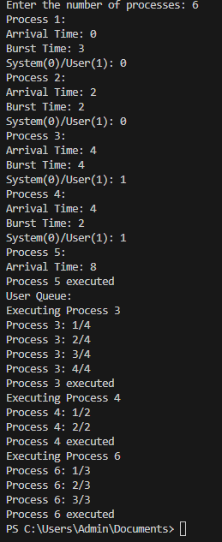

Q2) Rate Monotonic Scheduling.

INPUT:

#include<stdio.h>

#include<math.h>

int main()

{

  int n;

  float e[20],p[20];

  int i;

  float ut,u,x,y;

  printf("\n Enter Number of Processes: ");

  scanf("%d",&n);

  for(i=0;i<n;i++)

  {

   printf("\n Enter Execution Time for P%d:",(i+1));

   scanf("%f",&e[i]);

   printf("\n Enter Period for P%d:",(i+1));

   scanf("%f",&p[i]);

  }

  //calculate the utilization

  for(i=0;i<n;i++)

  {

   x=e[i]/p[i];

   ut+=x;

  }

  //calculate value of U

  y=(float)n;

  y=y*((pow(2.0,1/y))-1);

  u=y;

  if(ut<u)

  {

 printf("\n As %f < %f ,",ut,u);

 printf("\n The System is surely Schedulable");

  }

  else

 printf("\n Not Sure.....");

}

OUTPUT:

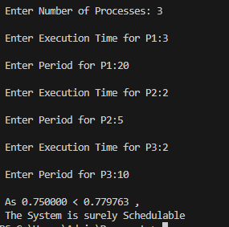

Q3) Earliest deadline First.

INPUT:

#include <stdio.h>

#include <stdlib.h>

#define MAX 10

int n,p,Q;

int period[MAX], execution[MAX], deadline[MAX];

int ready[MAX], task[MAX];

int time = 0;

void swap(int *a, int *b) {

    int temp = *a;

    *a = *b;

    *b = temp;

}

void sort() {

    for (int i = 0; i < n - 1; i++) {

        for (int j = i + 1; j < n; j++) {

            if (deadline[i] > deadline[j]) {

                swap(&period[i], &period[j]);

                swap(&execution[i], &execution[j]);

                swap(&deadline[i], &deadline[j]);

            }

        }

    }

}

void schedule() {

    int i, j;

    for (i = 0; i < n; i++) {

        if (time % period[i] == 0) {

            ready[i] = 1;

        }

    }

    for (i = 0; i < n; i++) {

        if (ready[i] == 1) {

            int min_deadline = 1000000000;

            int min_index = -1;

            for (j = 0; j < n; j++) {

                if (ready[j] == 1 && deadline[j] < min_deadline) {

                    min_deadline = deadline[j];

                    min_index = j;

                }

            }

            task[min_index] += execution[min_index];

            deadline[min_index] += period[min_index];

            ready[min_index] = 0;

        }

    }

}

int main() {

    printf("Enter the number of processes: ");

    scanf("%d", &n);

    printf("Enter the period, execution time and deadline of each process:\n");

        for (int i = 0; i < n; i++) {

        scanf("%d %d %d", &period[i], &execution[i], &deadline[i]);

        ready[i] = task[i] = 0;

    }

    sort();

printf("\nOrder of execution of processes in CPU timeline:\n");

    while (time < 100) { // assuming total time is 100

        schedule();

        printf("%d ", task[0]);

        time++;

    }

    return 0;

}

OUTPUT:

